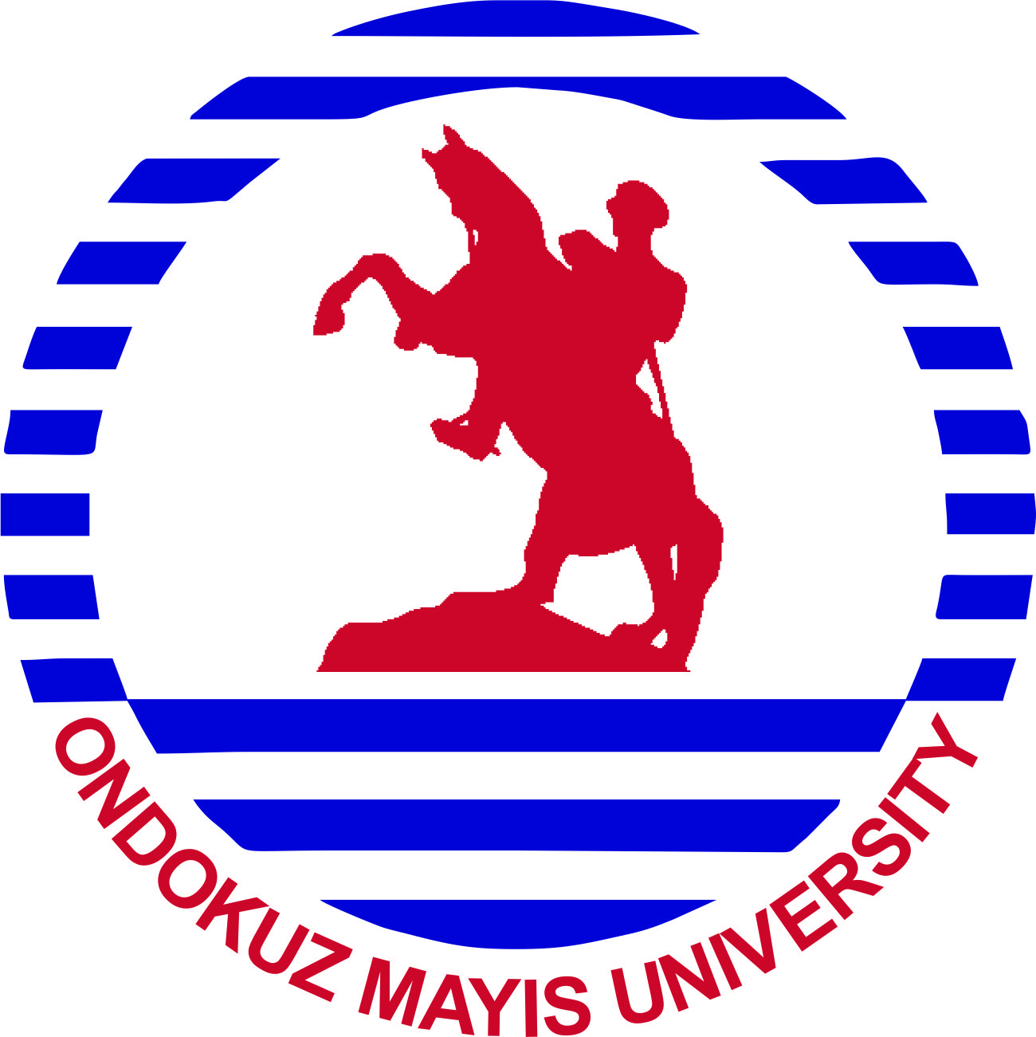
MEMORANDUM OF UNDERSTANDING

BETWEEN

ONDOKUZ MAYIS UNIVERSITY, TURKEY
and
………………, ………….

Article 1
This Memorandum of Understanding (hereafter referred to as “MoU”) comprises the joint scientific work and educational and cultural collaboration between Ondokuz Mayıs University and ………………...
Article 2
This MoU has been composed with the main aims of encouraging the research and educational approaches of Ondokuz Mayıs University and ……………. between the teaching staff, assistants, researchers, experts, and students of both universities, developing existing relations, enabling the joint use of research work results and publishing these results, and transferring the experiences of the parties in educational approaches and in joint scientific organizations.
Article 3
Both parties (Ondokuz Mayıs University and ……………) acknowledge and undertake the following articles that make up the whole of this MoU and the terms of its application for the realization of these articles.
Article 4
Both parties will work in the fields they will collaborate in within the framework determined above and the criteria clearly determined below, and they will exchange scientific knowledge, technological know-how, and experience. In this context:
Article 5
- Persons subject to academic exchange are teaching staff, research staff, and experts.
- The main priorities of teaching staff, research staff, and experts should be aimed at joint research, the development and transfer of knowledge, and the organization of study meetings.
- The other party will be notified of the names proposed by the proposing party within a reasonable time and the opinions of the other party concerning the candidate and its approval will be sent to the sending university at least two months in advance of the commencement of the scheduled visit.
- Each participant shall bear and be responsible for paying his or her own travel, housing expenses, meal costs, health insurance, and other miscellaneous fees. Upon request, the host institution agrees to use its best efforts to assist the teaching staff, research staff, and experts in making advance arrangements for their accommodation.
- The visiting teaching staff, research staff, and experts will benefit from all campus libraries and will take the privilege of them in accordance with the host university library regulations. They will also be provided a computer, printer, and internet access by the host university.
Article 6
- Both universities will endeavor to provide exchange for students with a scientific approach. The number of students to benefit from the exchange process will be determined by a joint commission to be formed following the signing of the MoU by both parties based on mutual understanding. The host university will be notified of the names and fields of education of the students determined by the sending university at least three months beforehand and the host university will announce its decision regarding applications to the other party at least 1 month before the commencement of the academic year.
- Both universities will exempt visiting students from charges such as education and registration fees. The principal procedure requires that such charges are paid at the institution to which the student is attached. All social payments other than education and registration fees will be met by students.
- Students - excluding tuition and registration fees - will be subject to the regulations of the host university. The sending university will accept the examinations of the host university and their results.
- For application, students will present a document demonstrating his/her language proficiency meeting the terms and level required by the host university.
- Each participant will be responsible for his/her travel expenses and expenses incurred from travel documents. Upon request, the host institution will assist the visiting student with suitable accommodation. Visiting students will also have the right to benefit from all the privileges of the campus (e.g. the use of libraries, student canteens, and social facilities, etc.) that native students have and at the same prices.
- Each participant should obtain health and accident insurance against any medical problems or accidents that may be faced during their exchange period in their own country prior to their travel. The insurance company and the limit of the insurance should be valid in the host country.
- Necessary procedures will be implemented for the recognition of awards, certificates, and documents of attendance awarded to the visiting student for participating in seminars, courses, etc during his/her stay at the host university.

Article 7
After having been approved and signed by both university authorities, this MoU will be considered valid for five (5) years. If none of the parties request a withdrawal three months before the end of the MoU duration in writing, the MoU will be extended for another five (5) years. Requests for withdrawal from the MoU before this date must be given in writing at least one (1) year prior to the termination of the five (5) year program.

…./…./2025 ..../…./2025

Prof. Dr. Fatma AYDIN ……………………
Rector ……….
Ondokuz Mayıs University …………………………..

